MEMORANDUM OF AGREEMENT
BETWEEN
MIAMI UNIVERSITY, SCRIPPS GERONTOLOGY CENTER
501 E. High Street, Oxford, OH 45056

AND
Client’s address here

Project period for this Agreement: From: ________ Through: __________

This Memorandum of Agreement (MOA), by and between Miami University, Scripps Gerontology Center and ______________________, is to conduct the following project: Opening Minds through Art (OMA): An Intergenerational Art Program for People with Dementia, at __________________.

Article I: Funding

OMA Programming at ________________ is being funded on a fixed-price basis for expenses incurred by Miami University in conducting the OMA project beginning __________ and ending ___________. Total compensation for this MOA is __________. (This amount does not include fees for supplies to provide an art show at the end of the semester, nor honorarium and travel of Lead Artist, which is to be paid to the Lead Artist directly.)

Article II: Payment of Funds

A. ______________ will mail payment to Miami University at the following address:
:
Miami University
Attn: Linda Manley, Grants & Contracts Manager
Grants and Contracts
Roudebush Hall, Room 7
Oxford, OH 45056-3653

B. For purposes of identification, the payment shall include the title of the project and the names of the project directors as follows:

Project Title: Opening Minds through Art (OMA): An Intergenerational Art Program for People with Dementia
Project Director: _________________

Article III: Responsibilities

A. Miami University, Scripps Gerontology Center shall:
1. Provide services for the OMA project.
2. Expend funds for supplies, services, and personnel in support of activities of the OMA project.

B. _________ shall:
- Reserve space during the time OMA session is active.
- Recruit volunteers as needed.
- Provide tablecloths, stools for the volunteers, and aprons for the volunteers and residents participating in OMA.
- Plan and fund OMA art show at least once per year (mats, frames, certificates, refreshments).
- Provide photographs of OMA participants and their volunteers, printed for the art show at least 10 days prior to the art show.
- Obtain consents (or declines) for using the photographs in OMA’s publicity from responsible parties.
- Provide honorarium and travel reimbursement for Lead Artist(s).
- Collaborate with the Project Director to provide the best experience possible for the participants in the OMA program.

Article IV: Key Personnel

A. For Miami University:

Project Director / Miami University Contact:
Project Director: ____________
Contact info here: _____________

Miami University Fiscal Contact:
Linda K. Manley, Grants & Contracts Manager
Miami University
Grants & Contracts
Roudebush Hall, Room 7
Oxford, OH 45056-3653
Telephone: (513) 529-5405
Fax: (513) 529-6124
E-mail: manleylk@miamioh.edu

Miami University Authorized Administrative Representative:
Anne P. Schauer, Director, Research & Sponsored Programs
Miami University
Roudebush Hall, Room 102
Oxford, OH 45056-3653
Telephone: (513) 529-3600
Fax: (513) 529-3762
E-mail: schauerap@miamioh.edu

B. For ___________________ (Client):

Client’s Contact person: ____________
Address, tel., email: ____________

Article V: Terms of Agreement

- Period of performance will be the same period written into the heading of this Agreement.

- This Agreement may be modified or extended only by written amendment executed by all parties hereto.

- At least thirty (30) days written notice between the Authorized Administrative Representatives is required before either party may initiate termination proceedings.

Article VII: Acknowledgment

The parties acknowledge that they have read and understand the foregoing Agreement and that such provisions are reasonable and enforceable, and agree to abide by this Agreement and the terms and conditions set forth herein.

IN WITNESS WHEREOF, the parties hereto set forth their respective signatures on this Agreement as of the dates set forth below.

MIAMI UNIVERSITY

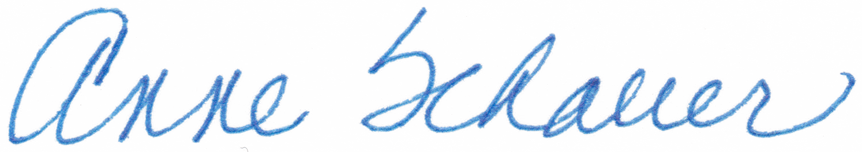

Anne P. Schauer, Director, Research & Sponsored Programs Date

Client’s Signature:

_______________________________________ __________________
Print name: ______________ Date

